
International School

Capstone Project 2
CMU-SE 451

User Interface Document
Version 2.3
Date: Apr 09, 2022

Pet Care and Supervision Services

Submitted by

Truong Le Dai
Nguyen Hong Hieu
Tran Thi Chung
Le Quang Van

Approved by
Dr. Nguyen Tan Thuan

.
Proposal Review Panel Representative:

Name Signature Date

Capstone Project 1- Mentor: Dr. Nguyen Tan Thuan

Name Signature Date
PROJECT INFORMATION

Project acronym | PetCare
Project Title | Pet Care And Supervision Services
Start Date | 26 Feb 2022 |  | End Date | 06 May 2022
Lead Institution | International School, Duy Tan University
Project Mentor | Dr. Nguyen Tan Thuan
Scrum master / Project Leader & contact details | Truong Le Dai  Email:daicatimmai123v30@gmail.com  Tel: 0774443926
Partner Organization
Project Web URL | Localhost:4444/Vets/Home
Team members | Name | Email |  | Tel
24211407122 | Truong Le Dai |  | daicatimmai123v30@gmail.com | 799400038
24211205523 | Nguyen Hong Hieu |  | nguyenhonghieuit@gmail.com | 777903474
24201402277 | Tran Thi Chung |  | tranchung10a3@gmail.com | 945228146
24211401402 | Le Quang Van |  | vanlequang00@gmail.com | 898163596

User Interface Document

Document Title | User Interface
Reporting Period | 26 Feb 2022
Author(s) & project | Truong Le Dai, Scrum Master
Role | Nguyen Hong Hieu | Member
 | Tran Thi Chung | Member
 | Le Quang Van | Member
Date | 23 Apr 2022 | Filename |  | C2SE.27-User Interface-PetCare.doc
URL
Access | Project and CMU Program

REVISION HISTORY

Version | Date | Comments | Author | Approval
1.0 | 20 Sept 2021 | Initial | C2SE.27 Team | All Team
1.1 | 21 Sept 2021 | Update document | C2SE.27 Team | All Team
1.2 | 05 Oct 2021 | Update document | C2SE.27 Team | All Team
1.3 | 21 Oct 2021 | Update document | C2SE.27 Team | All Team
1.4 | 07 Nov 2021 | Update document | C2SE.27 Team | All Team
2.0 | 26 Feb 2022 | Design UI for sprint 1 | C2SE.27 Team | All Team
2.1 | 12 Mar 2022 | Design UI for sprint 2 | C2SE.27 Team | All Team
2.2 | 26 Mar 2022 | Design UI for sprint 3 | C2SE.27 Team | All Team
2.3 | 09 Apr 2022 | Design UI for sprint 4 | C2SE.27 Team | All Team

DOCUMENT APPROVALS
The following signatures are required for approval of this document
Dr. Nguyen Tan Thuan  Mentor |  | Date:
Truong Le Dai  Scrum Master |  | Date:
Nguyen Hong Hieu  Product Owner |  | Date:
Tran Thi Chung  Member |  | Date:
Le Quang Van  Member |  | Date:

Table of Contents
1. Introduction 7
1.1. Purpose 7
1.2. Scope 7
2. List of User Interface for Sprint 7
2.1. Mobile App 7
2.2. Web 8
3. Describe User Interface of mobile app 10
3.1. UI-01: Welcome screen 11
3.2. UI-02: Login 11
3.3. UI-03: Register 12
3.4. UI-04: Verify OTP 13
3.5. UI-05: Home 14
3.6. UI-06: Appointment 15
3.7. UI-07: Pet List 16
3.8. UI-08: News 20
3.9. UI-09: Setting (Skip) 21
3.10. UI-10: Search Results (Skip) 22
3.11. UI-11: Liquidation 22
3.12. UI-12: Liquidation Post 23
3.13. UI-13:Liquidation detail 24
3.14. UI-14: Locate Pet 25
3.15. UI-15: Chat 26
4. Design User Interface of web 27
4.1. UI 01: Header 27
4.2. UI 02: Footer 27
4.3. UI 03: Menu Bar 28
4.4. UI 04: Homepage (logged out) 33
4.5. UI 05: Login 34
4.6. UI 06: Register 35
4.7. UI 07: Verify OTP 36
4.8. UI 08: Homepage (logged in) 37
4.9. UI 09: Pet List 38
4.10. UI 10: Pet profile 40
4.11. UI 11: Appointment 41
4.12. UI 12: Vet list 46
4.13. UI 13: Vet profile 49
4.14. UI 14: Facility List 50
4.15. UI 15: Facility profile 52
4.16. UI 16: Document 53
4.17. UI 17: Help 55
4.18. UI 18: Chat 56
4.19. UI 19: Liquidation 57
4.20. UI 20: Liquidation detail 58
4.21. UI 21: Liquidation post 59
4.22. UI 22: Statistical 60
4.23. UI 23: Video call 61
4.24. UI 24: Notification dropdown 61

Introduction

Purpose
This document describes the design interface of “PetCare”: Pet Care and Supervision Services”.

Scope
- Overview of the stages and modules of the software.
- Create a complete interface and describe them clearly.

List of User Interface for Sprint

Mobile App
Roles | User Interface ID | UI Name | Description | Notes
Pet Owner | UI-01 | Welcome screen | This is used for introduce to user about our login, app name and slogan
Pet Owner | UI-02 | Login | This is used for users to login into the app.
Pet Owner | UI-03 | Register | This screen is used for user to create new account
Pet Owner | UI-04 | Verify OTP | This screen where user input the OTP code sent to their phone for verification
Pet Owner | UI-05 | Home | This screen is the homepage of the app.
Pet Owner | UI-06 | Appointment | This screen shows the appointments for health check up.
Pet Owner | UI-07 | Pet List | This screen shows a list of pets.
Pet Owner | UI-08 | News | This screen shows a list of news.
Pet Owner | UI-10 | Search Result | This screen shows the list of results from the search bar.
Pet Owner | UI-11 | Liquidation | This screen shows image and name products
Pet Owner | UI-12 | Liquidation post | This page shows condition fields provide information for the post.
Pet Owner | UI-13 | Liquidation detail | This page shows detailed product information, including comments
Pet Owner | UI-14 | Locate Pet | This screen shows pet’s location
Pet Owner | UI-15 | Chat | This is the live chat box.

Web
Roles | User Interface ID | UI Name | Description | Notes
All | UI-01 | Header | This is the header of the website.
All | UI-02 | Footer | This is the footer of the website.
All | UI-03 | Menu bar | These are the menu bar in 3 different views: Manager, Pet Owners, Veterinarian.
All | UI-04 | Homepage (logged out) | This page is the homepage of the website when there’s no user logged in.
All | UI-05 | Login | This page allows users to login to their account.
Pet Owner | UI-06 | Register | This screen is used for user to create new account
Pet Owner | UI-07 | Verify OTP | This screen where user input the OTP code sent to their phone for verification
All | UI-08 | Homepage (logged in) | This page is the homepage.
Pet Owner and Vet | UI-09 | Pet List | This page shows a list of available pets.
Pet Owner and Vet | UI-10 | Pet Profile | This page shows information about a pet.
All | UI-11 | Appointment | This page shows the detail and status of the appointments on the calendar.
All | UI-12 | Veterinarian List | This page shows a list of veterinarians.
All | UI-13 | Veterinarian Profile | This page shows the information of a veterinarian.
All | UI-14 | Facility List | This page shows a list of nearby veterinary facilities.
All | UI-15 | Facility Profile | This page shows the information about a facility to pet owners and vets.
All | UI-16 | Documents | This page shows a list of documents and catalogs uploaded by the veterinarian.
All | UI-17 | Help | This page is for customer support and FAQs.
All | UI-18 | Chat | This is the integrated live chat.
All | UI-19 | Liquidation | This screen shows image and name products
All | UI-20 | Liquidation detail | This page shows condition fields provide information for the post.
All | UI-21 | Liquidation detail post | This page shows detailed product information, including comments
Manager and Veterinarian | UI-22 | Statistical report | This page shows the statistical report.
All | UI-23 | Video call | This is the integrated video call.
All | UI-24 | Notification dropdown | This is the notification box.

Describe User Interface of mobile app

UI-01: Welcome screen
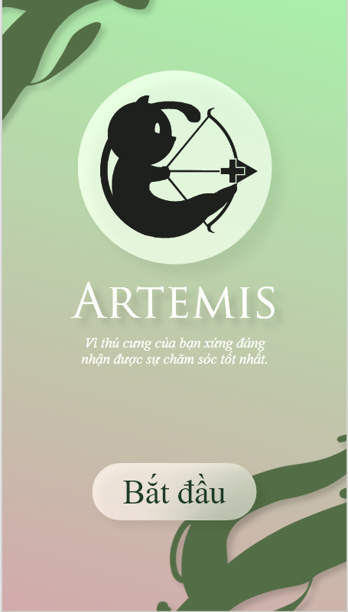

From | Condition | Control Type | Target | Notes
1 | View | Image | Show application logo
2 | View | Label | Show application name
3 | View | Label | Show application slogan
4 | Click | Button | Click to move on to application

UI-02: Login
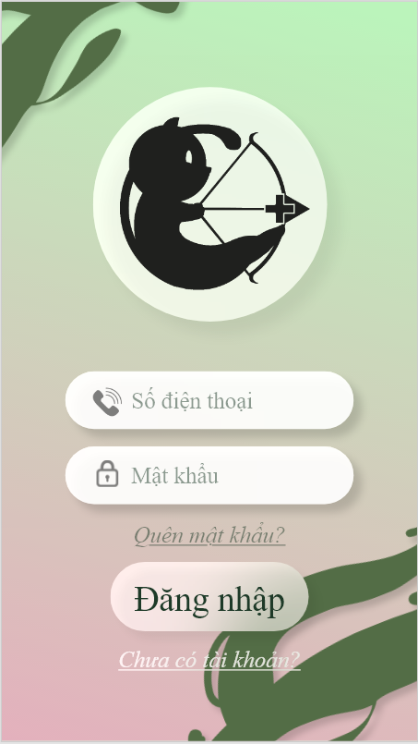

From | Condition | Control Type | Target | Notes
1 | View | Image | Show application logo
2 | Input | EditText | Input phone number
3 | Input | EditText | Input password
4 | Click | Label | Forget password
5 | Click | Button | Login
6 | Click | Label | Create new account

UI-03: Register
From | Condition | Control Type | Target | Notes
1 | Input | EditText | Input name
2 | Input | EditText | Input phone number
3 | Input | Date | Input DOB
4 | Input | EditText | Input password
5 | Input | EditText | Re-input password

UI-04: Verify OTP
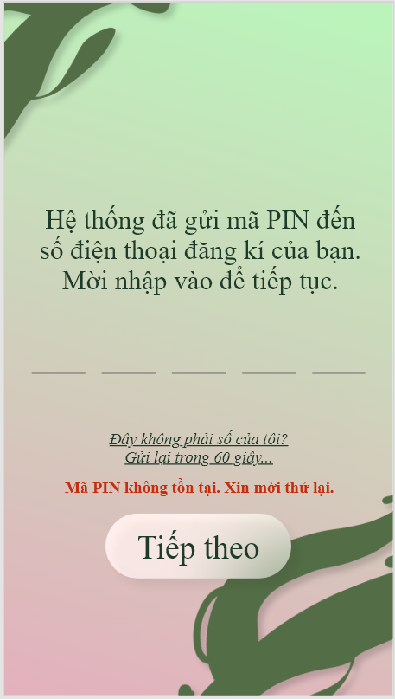
From | Condition | Control Type | Target | Notes
1 | View | Label | Show text
2 | Input | Number | Input verification code
3 | Click | Label | Click to return to previous screen
4 | Click | Label | Click to return to resend code
5 | View | Label | Show text
6 | Click | Button | Click to continue

UI-05: Home
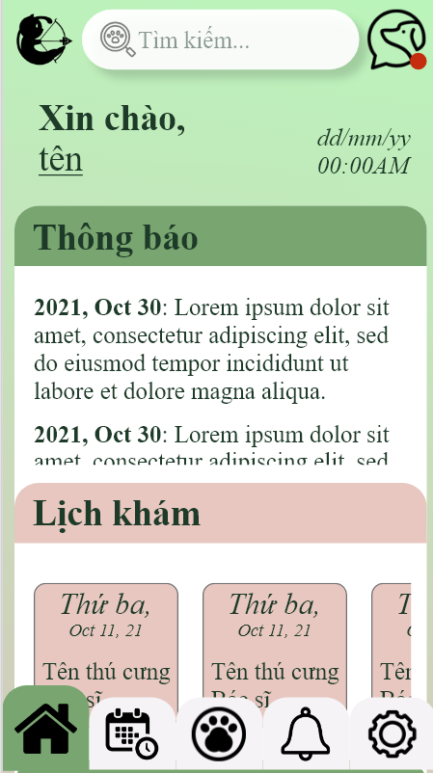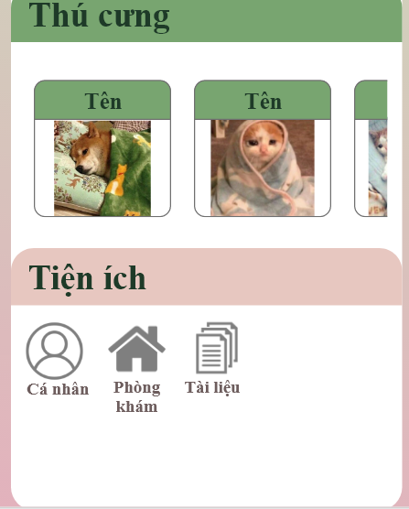
From | Condition | Control Type | Target | Notes
1 | View | Image | Show logo
2 | Input | EditText | Input search query
3 | Click | ImageButton | Click to chat
4 | View | Label | Show text
5 | View | Date | Show current date
6 | View | Container | Show main contents
7 | Click | Menu Tab | Use to navigate

UI-06: Appointment
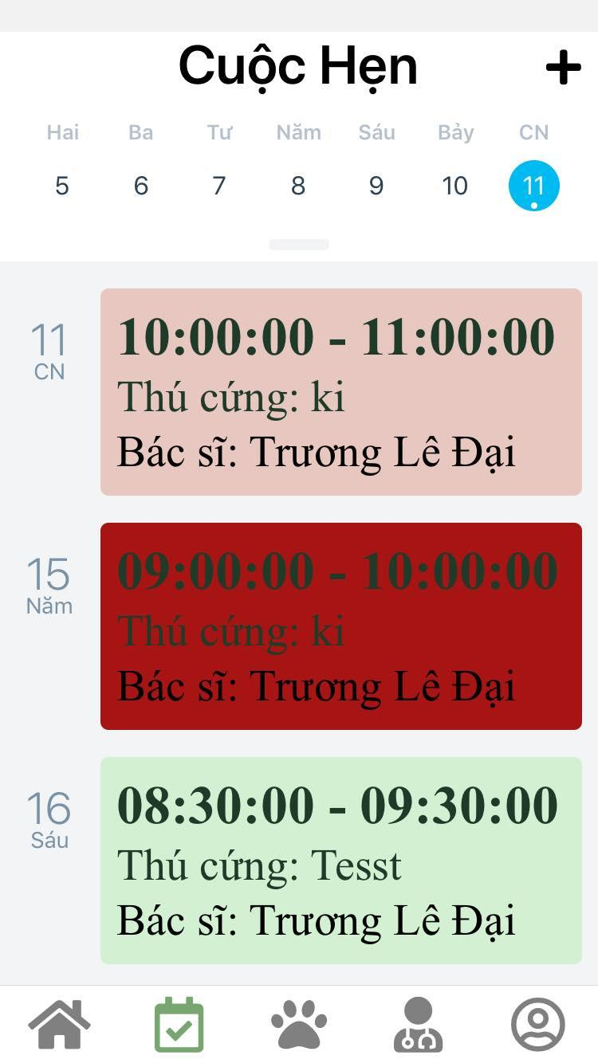
From | Condition | Control Type | Target | Notes
1 | View | Label | Show text
2 | Click | Calendar | Pick date from calendar
3 | Click | Container | Click on appointment item to show appointment info

UI-07: Pet List
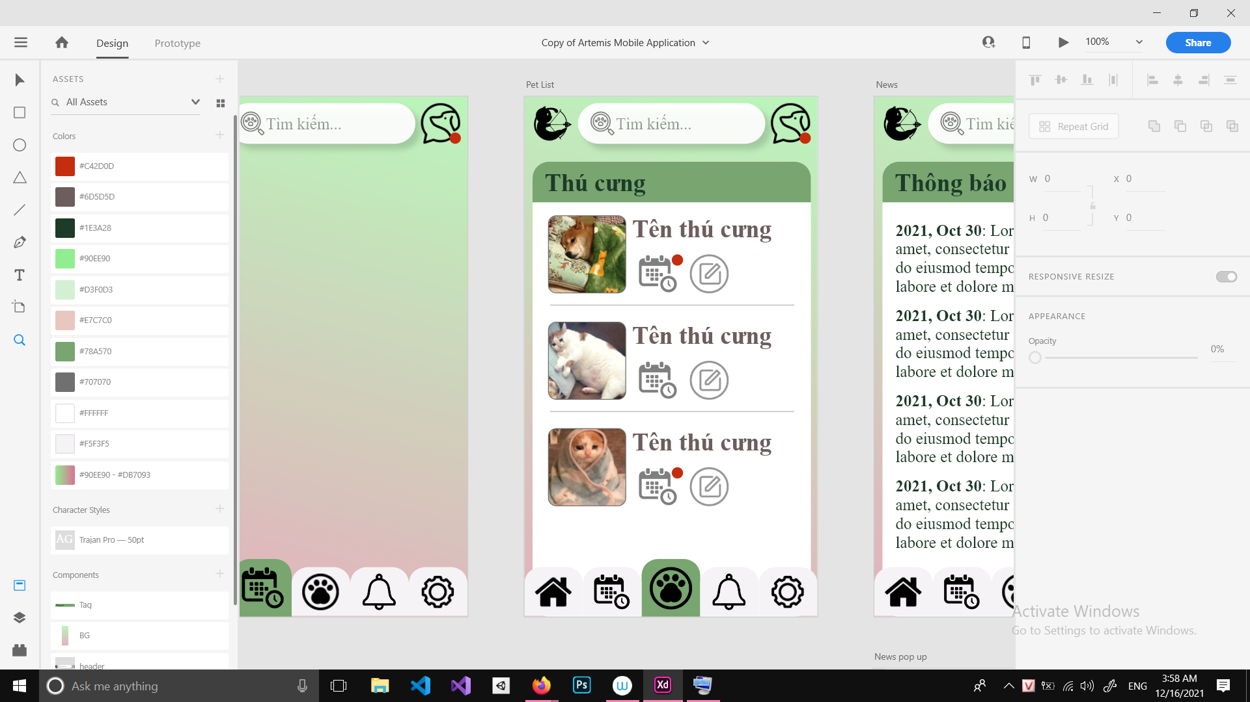

From | Condition | Control Type | Target | Notes
1 | View | Label | Show tab title
2 | Click | Container | Show tab contents, click to show pet profile pop-up

From | Condition | Control Type | Target | Notes
1 | View | Image | Show pet avatar
2 | View | Label | Show pet name
3 | Click | ImageButton | Click to move to appointment tab
4 | Click | ImageButton | Click to edit pet profile
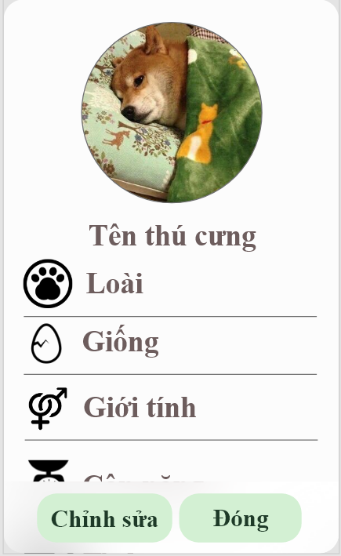

From | Condition | Control Type | Target | Notes
1 | View | Image | Show pet avatar
2 | View | Label | Show pet name
3 | View | Number | Show pet species
4 | View | Label | Show pet breed
5 | View | Label | Show pet gender
6 | View | Label | Show pet weight
7 | Click | Button | Click to edit
8 | Click | Button | Click to close pop-up

UI-08: News
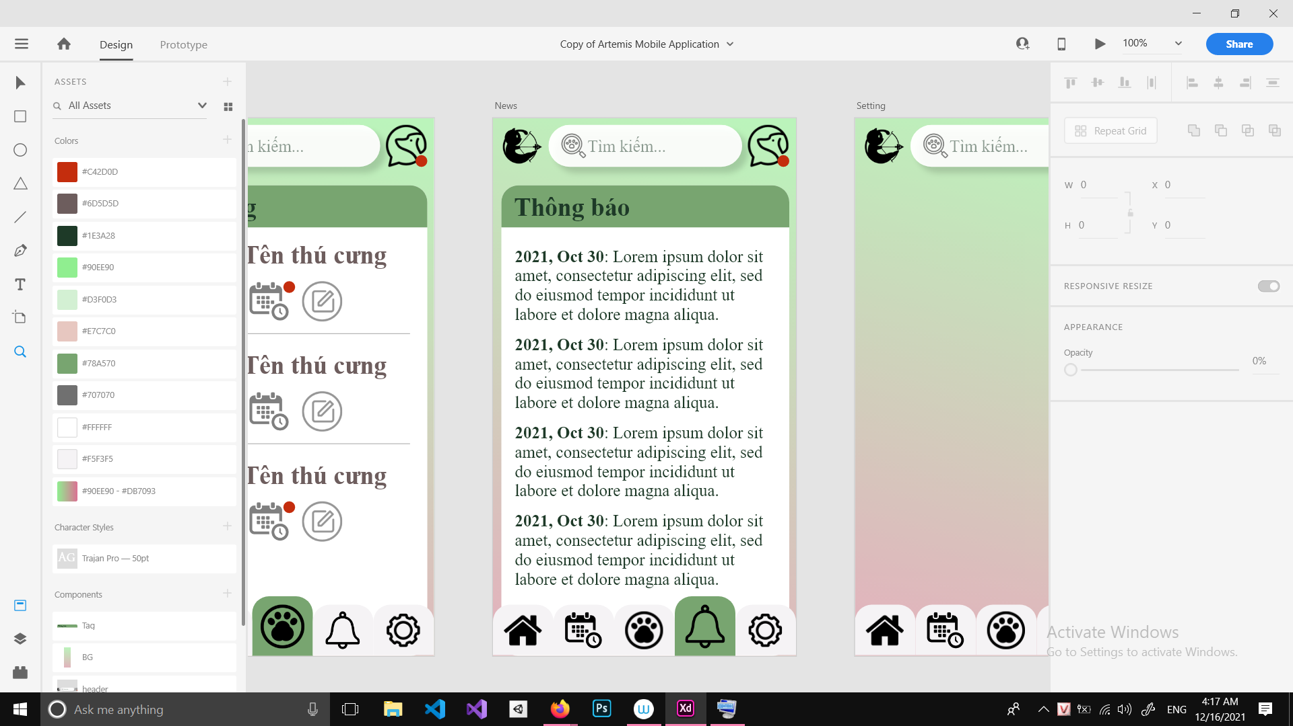

From | Condition | Control Type | Target | Notes
1 | View | Label | Show tab title
2 | Click | Container | Show tab contents, click to show news pop-up

From | Condition | Control Type | Target | Notes
1 | View | Label | Show text
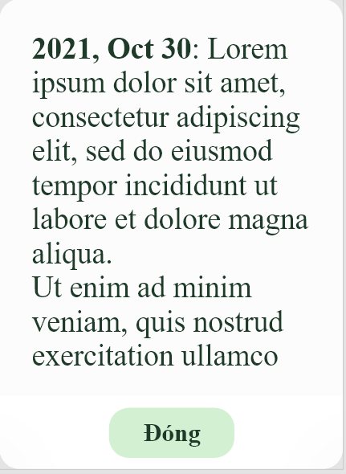

From | Condition | Control Type | Target | Notes
1 | View | Label | Show text
2 | Click | Button | Click to close pop-up

UI-09: Search Results
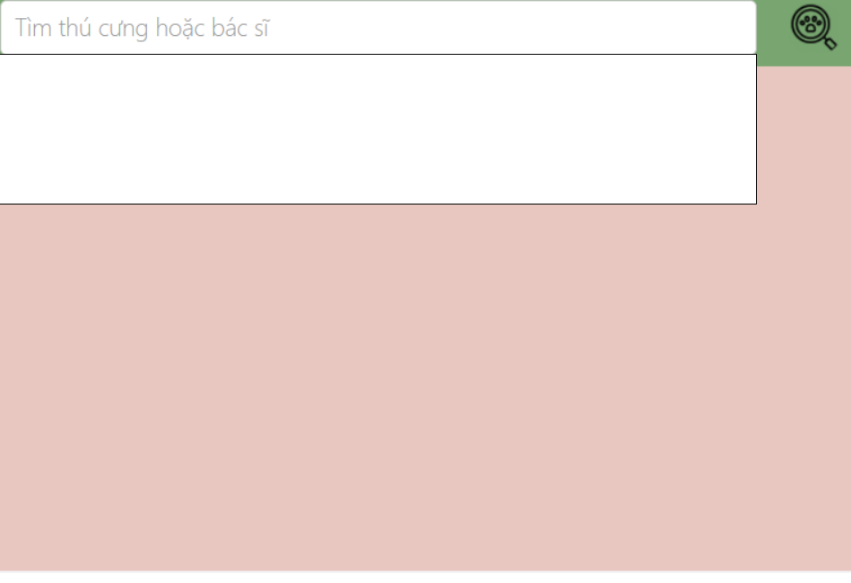

From | Condition | Control Type | Target | Notes
1 | Input | Edit Text | Input pet or veterinarian by name
2 | Click | Button | Click to find items
3 | View | Text view | Show results

UI-10: Liquidation
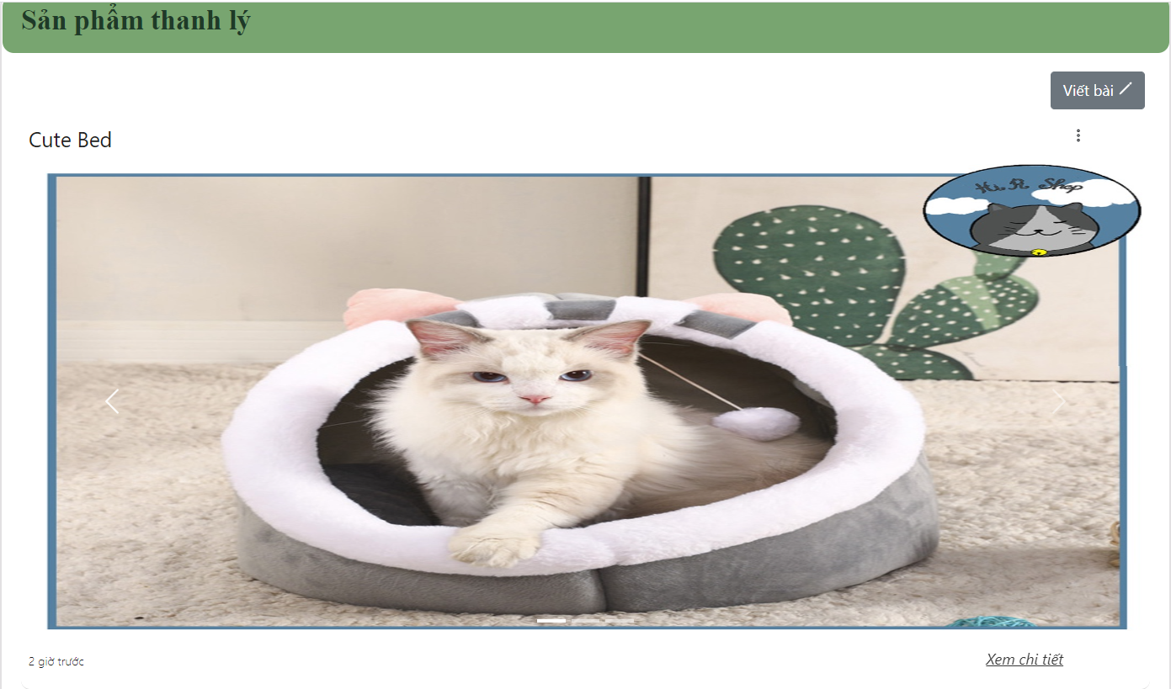

From | Condition | Control Type | Target | Notes
1 | View | Text View | Show title
2 | View | Text View | Show text
3 | Click | Button | Click to create post
4 | Click | Button | Click to show action (edit/delete)
5 | View | Img | Show Img for item
6 | Click | Button | Click to navigate to page detail
7 | View | Text View | Show time

UI-11: Liquidation Post
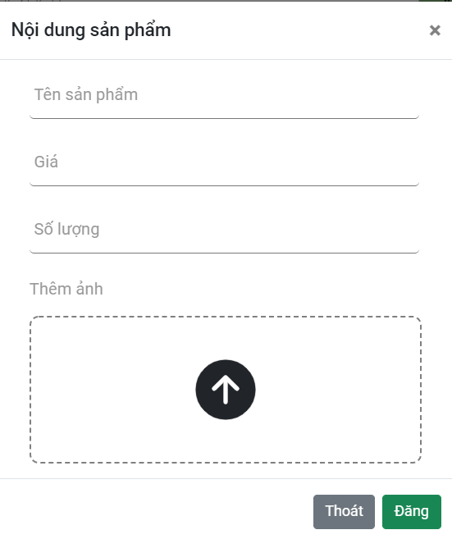
From | Condition | Control Type | Target | Notes
1 | View | Text View | Show title
2 | Input | Edit text | Input product ‘s name
3 | Input | Edit text | Input price
4 | Input | Edit text | Input quantity
5 | Input | Img | Attach a photo of the product.
6 | Click | Button | Click to exit the form
7 | Click | Button | Click here to finish the post.

UI-12:Liquidation detail
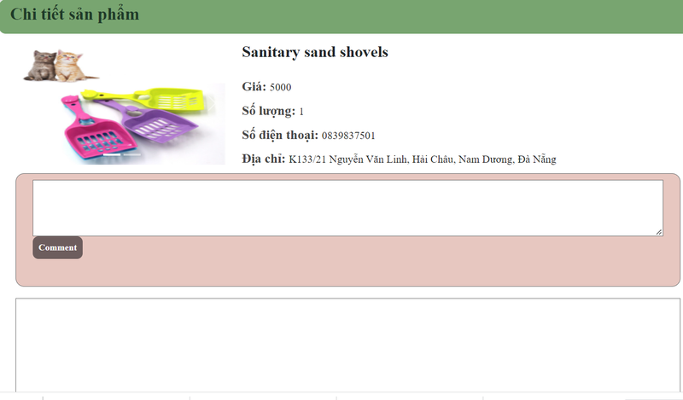
From | Condition | Control Type | Target | Notes
1 | View | Text View | Show title
2 | View | Text View | Show text
3 | View | Text View | Show price
4 | View | Text View | Show quality
5 | View | Text View | Show phone number
6 | View | Text View | Show address
7 | View | Edit Text | Input comment
3 | Click | Button | Click to finish the comment
4 | View | Text View | Show all comment

UI-13: Locate Pet
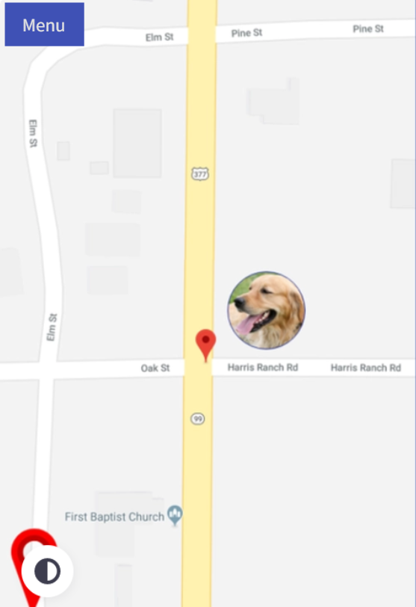
From | Condition | Control Type | Target | Notes
1 | Click | Menu | Click to view menu options
2 | View | Map | View Pet location

UI-14: Chat
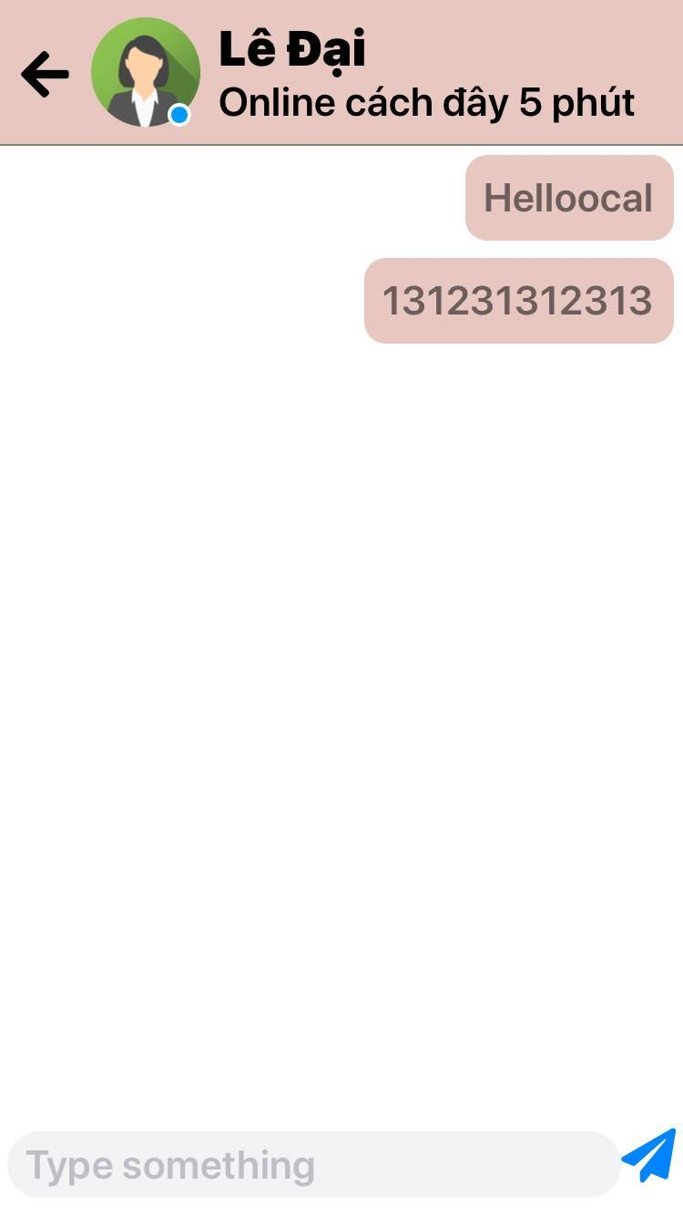

From | Condition | Control Type | Target | Notes
1 | Click | ImageButton | Click to close chat box
2 | Click | ImageButton | Click to view user profile
3 | View | Text View | Show user name
4 | View | Text View | Show user status
5 | Input | Edit Text | Input message
6 | Click | Button | Click to send message

Design User Interface of web

UI 01: Header
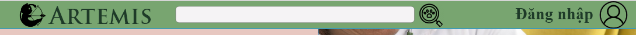
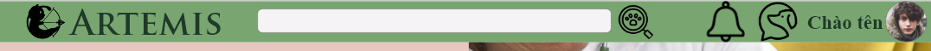

From | Condition | Control Type | Target | Notes
1 | View | Image | Show logo of team
2 | View | Text view | Show application name
3 | Input | Input Text | Input search query
4 | Click | Image | Click to go to search results
5 | Click | Image | Click to show notification
6 | Click | Image | Click to show chat
7 | Click | Text view | Click to open user profile
8 | View | Image | Show user avatar

UI 02: Footer
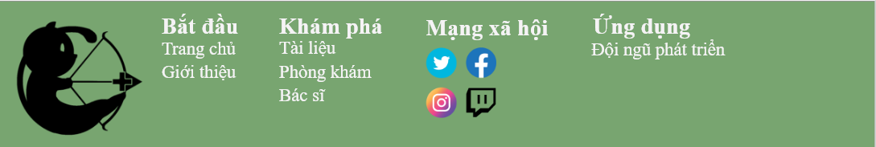

From | Condition | Control Type | Target | Notes
1 | View | Image | Show logo of team
2 | View | Text View | Show text | <Bắt đầu>
3 | Click | HyperLink | Click to return to homepage
4 | Click | HyperLink | Click to go to vet’s catalog
5 | View | Text View | Show text | <Khám phá>
6 | Click | HyperLink | Click to go to document page
7 | Click | HyperLink | Click to go to facility list page
8 | View | Text View | Show text | <Mạng xã hội>
9 | click | Image | Click to go to vet’s social media page | Twitter
10 | click | Image | Click to go to vet’s social media page | Facebook
11 | click | Image | Click to go to vet’s social media page | Instagram
12 | click | Image | Click to go to vet’s social media page | Twitch
13 | View | Text View | Show text | <Ứng dụng>
14 | Click | HyperLink | Click to go to the team’s page

UI 03: Menu Bar
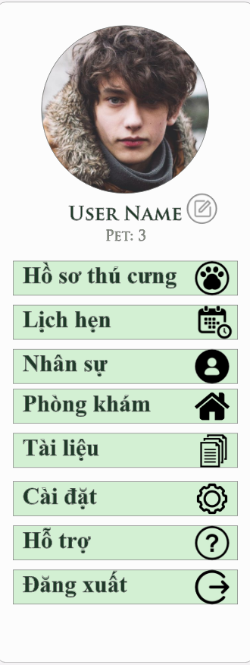
Pet Owner’s view

From | Condition | Control Type | Target | Notes
1 | View | Image | Show user avatar
2 | View | Text view | Show user name
3 | Click | Image | Click to go to user profile edit
4 | View | Text View | Show number of pet in Pet List
5 | Click | Button | Click to go to Pet List
6 | Click | Button | Click to go to Appointment
7 | Click | Button | Click to go to Vet List
8 | Click | Button | Click to go to Facility List
9 | Click | Button | Click to go to Document
10 | Click | Button | Click to go to Setting
11 | Click | Button | Click to go to Help
12 | Click | Button | Click to log out

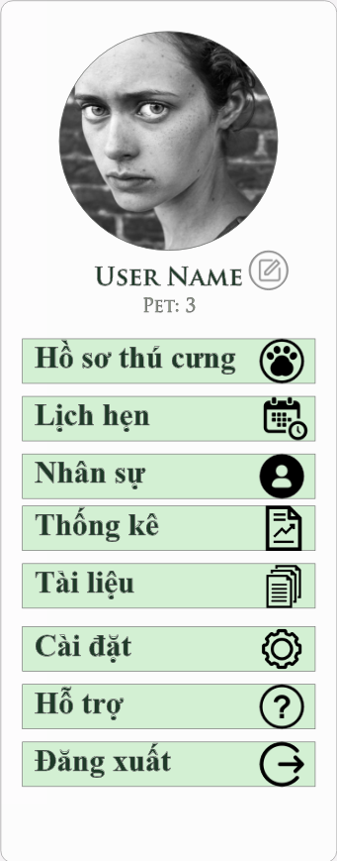
Vet’s view

From | Condition | Control Type | Target | Notes
1 | View | Image | Show user avatar
2 | View | Text view | Show user name
3 | Click | Image | Click to go to user profile edit
4 | View | Text View | Show number of pet in Pet List
5 | Click | Button | Click to go to Pet List
6 | Click | Button | Click to go to Appointment
7 | Click | Button | Click to go to Vet List
8 | Click | Button | Click to go to Statistical report
9 | Click | Button | Click to go to Document
10 | Click | Button | Click to go to Setting
11 | Click | Button | Click to go to Help
12 | Click | Button | Click to log out

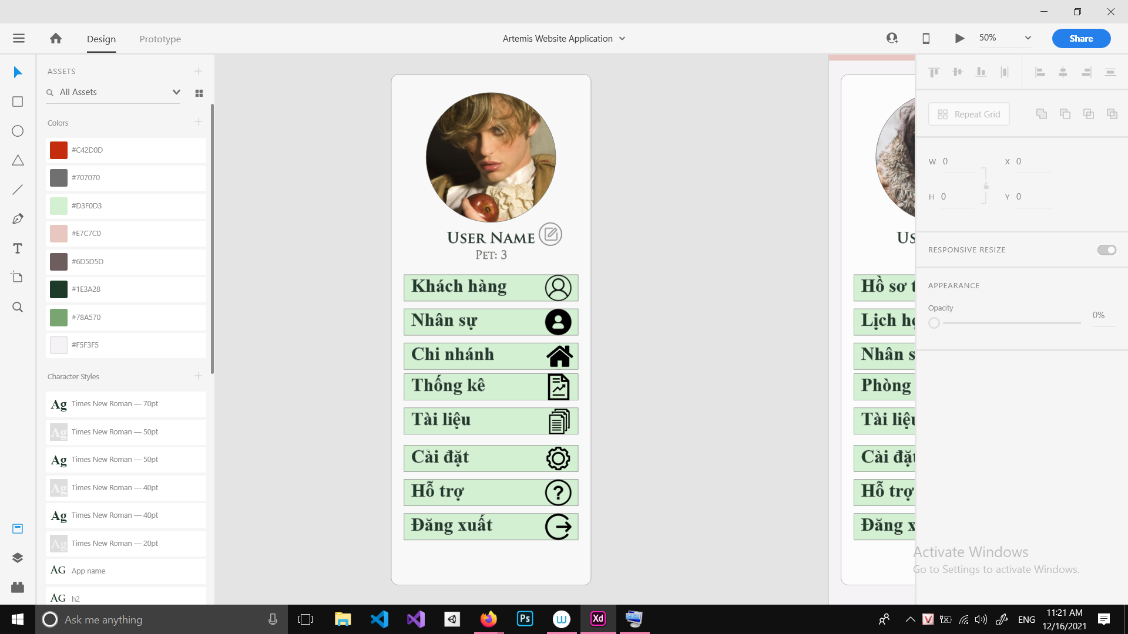
Admin’s view

From | Condition | Control Type | Target | Notes
1 | View | Image | Show user avatar
2 | View | Text view | Show user name
3 | Click | Image | Click to go to user profile edit
4 | Click | Button | Click to go to User List
5 | Click | Button | Click to go to Vet List
7 | Click | Button | Click to go to Facility List
8 | Click | Button | Click to go to Statistical report
9 | Click | Button | Click to go to Document
10 | Click | Button | Click to go to Setting
11 | Click | Button | Click to go to Help
12 | Click | Button | Click to log out

UI 04: Homepage (logged out)
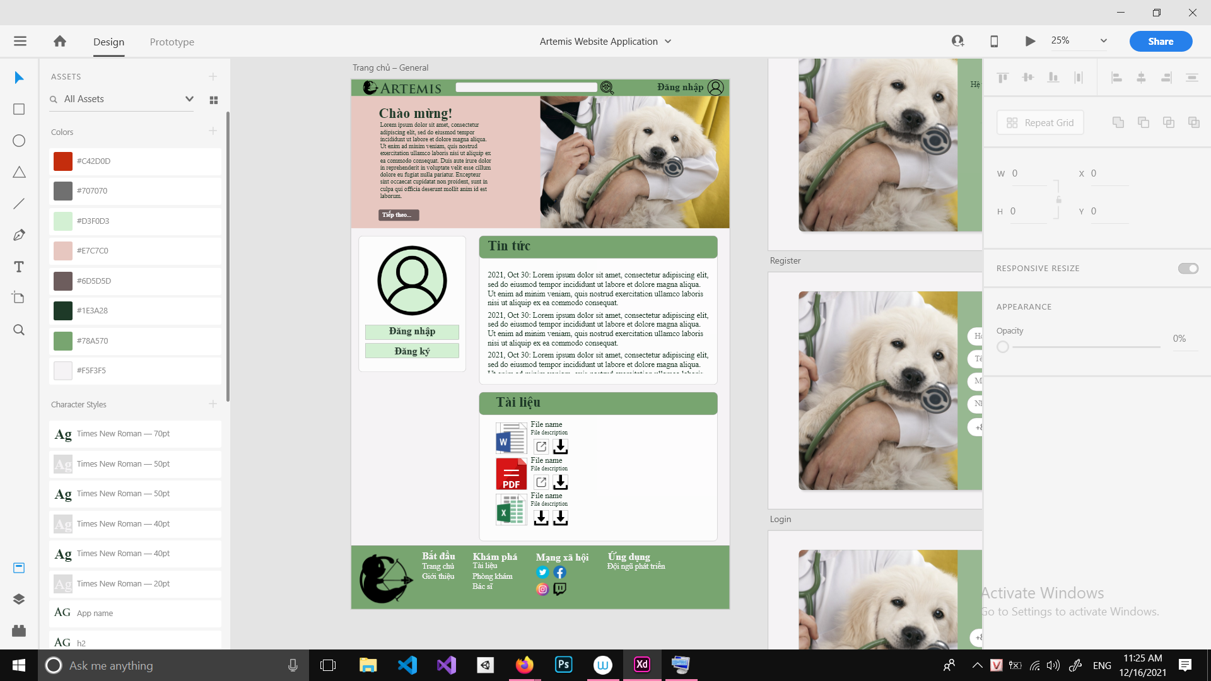

From | Condition | Control Type | Target | Notes
1 | View | Text View | Show text | <Chào mừng>
2 | View | Text View | Show text
3 | Click | Button | Click to go to vet’s catalog
4 | Navigate | Menu bar | For user to sign in or log in
5 | Click | Container | Click to show content | <Tin tức>
6 | Click | Container | Click to show document list | <Tài liệu>

UI 05: Login
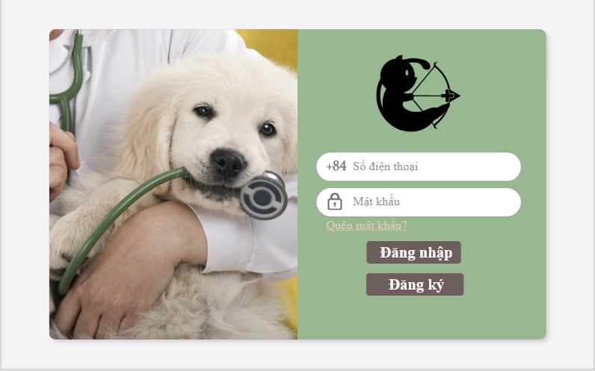
From | Condition | Control Type | Target | Notes
1 | View | Image | Show Image
2 | View | Image | Show team’s logo
3 | Input | Edit Text | Input phone number
4 | Input | Edit Text | Input password
5 | Click | hyperlink | Forget password
6 | Click | Button | Click to log in
7 | Click | Button | Click to register

UI 06: Register
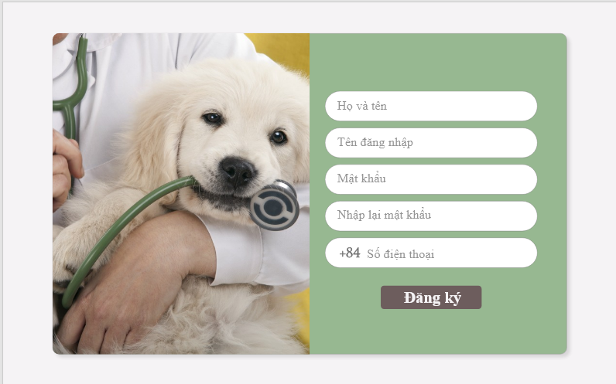

From | Condition | Control Type | Target | Notes
1 | View | Image | Show image
2 | Input | Edit Text | Input name
3 | Input | Edit Text | Input username
4 | Input | Edit Text | Input password
5 | Input | Edit Text | Re-input password
6 | Input | Edit Text | Input phone number
7 | Click | Button | Register

UI 07: Verify OTP
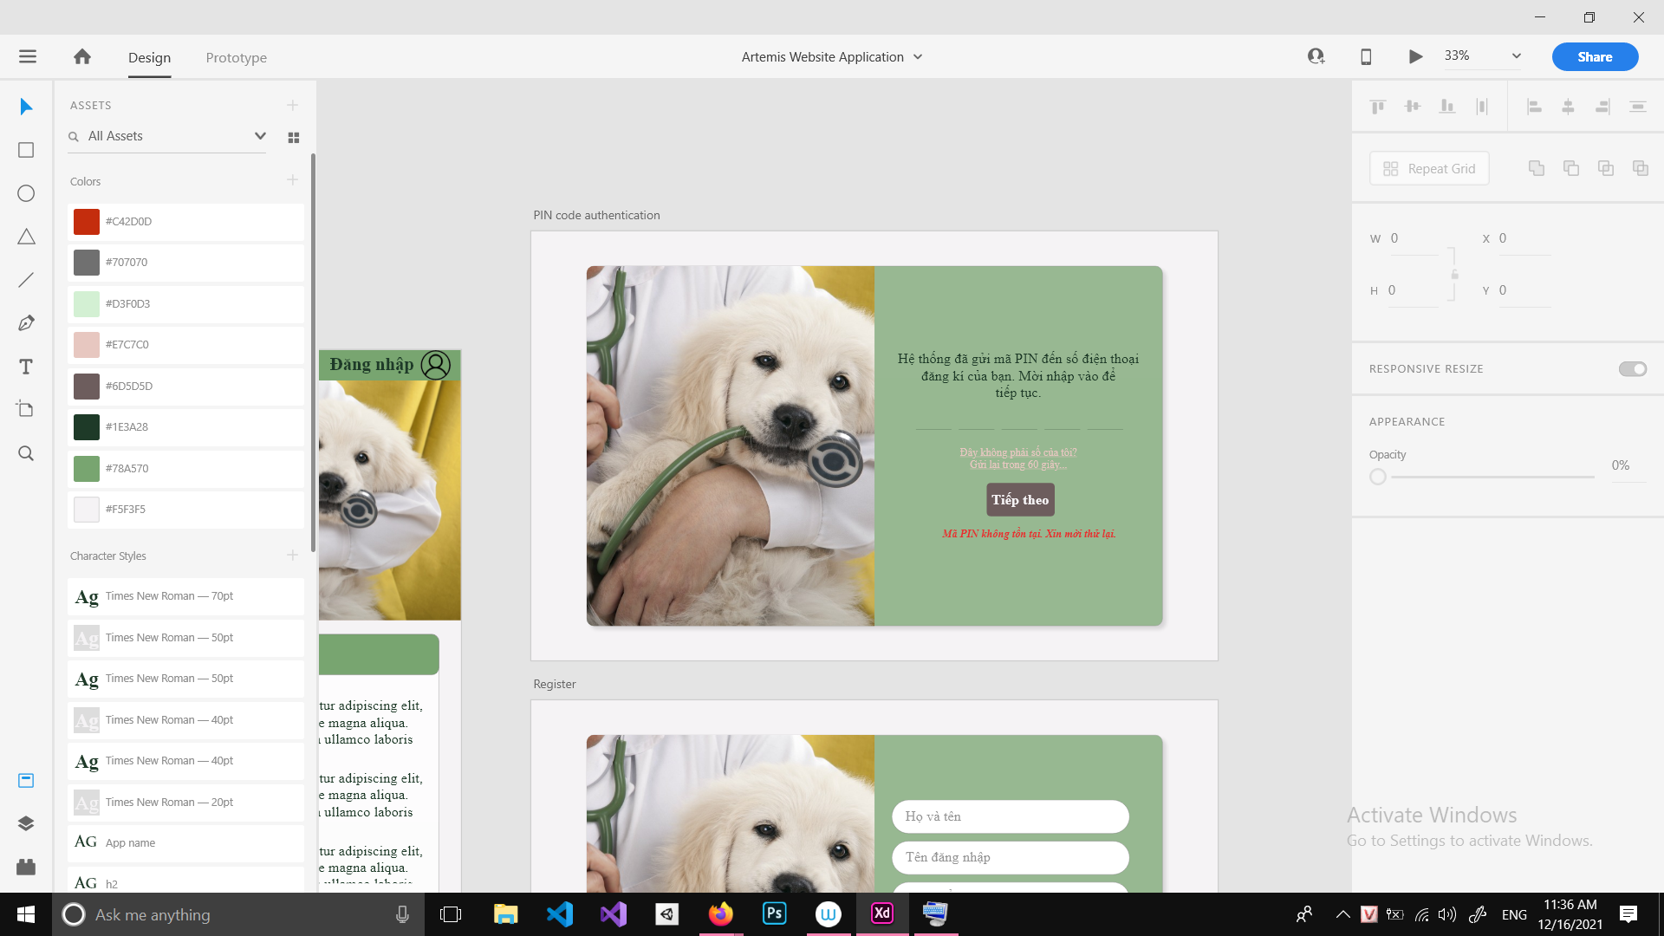
From | Condition | Control Type | Target | Notes
1 | View | Image | Show image
2 | View | Text view | Show text
3 | Input | Number | Input OTP code
4 | Click | hyperlink | Click to return to previous page
5 | Click | hyperlink | Click to resend the code
6 | Click | Button | Click to move on
7 | View | Text view | Show warning

UI 08: Homepage (logged in)
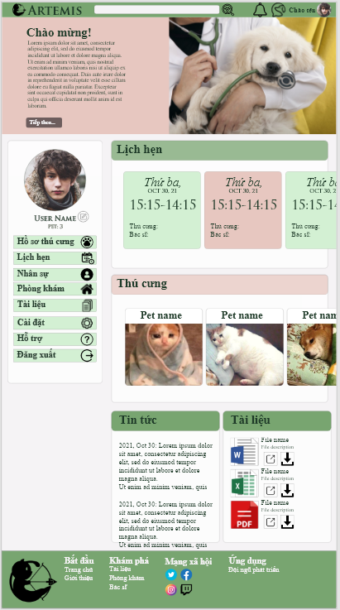

From | Condition | Control Type | Target | Notes
1 | View | Text View | Show text | <Chào mừng>
2 | View | Text View | Show text
3 | Click | Button | Click to go to vet’s catalog
4 | Navigate | Menu bar | For user to sign in or log in
5 | Click | Container | Click to show Appointment | <Lịch hẹn>
6 | Click | Container | Click to show Pet List | <Thú cưng>
7 | Click | Container | Click to show content | <Tin tức>
8 | Click | Container | Click to show document list | <Tài liệu>

UI 09: Pet List
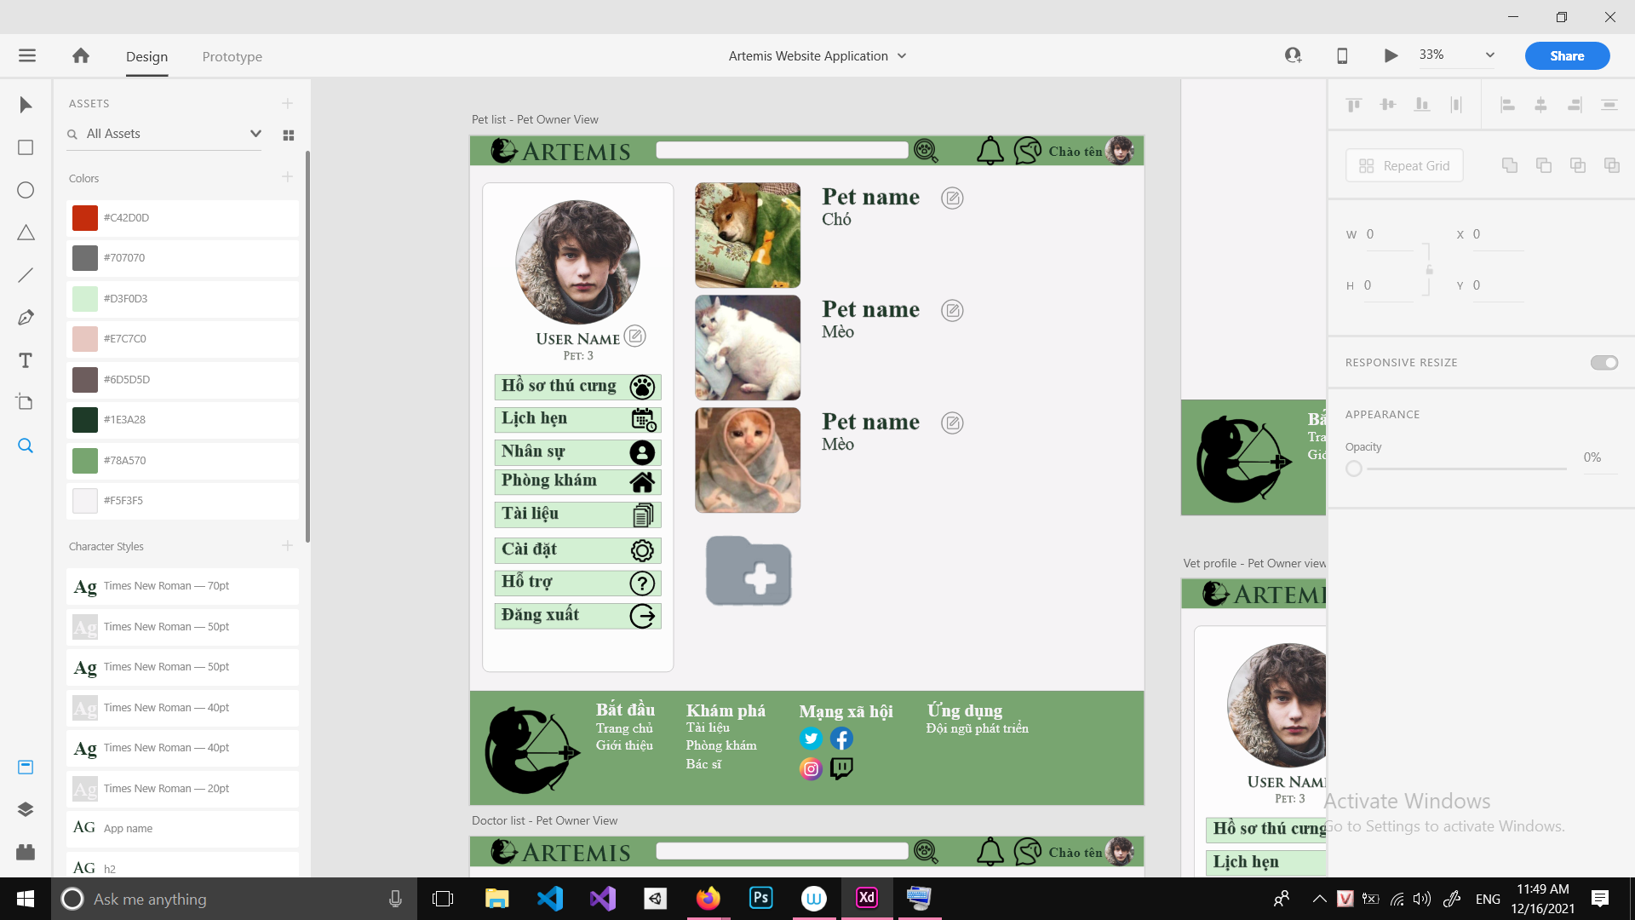

From | Condition | Control Type | Target | Notes
1 | Click | Container | Click on pet item to go to pet profile
2 | Click | Button | Click to add pet profile

From | Condition | Control Type | Target | Notes
1 | View | Image | Show pet avatar
2 | View | Text View | Show pet name
3 | Click | Button | Click to edit pet profile
4 | View | Text View | Show pet species

UI 10: Pet profile
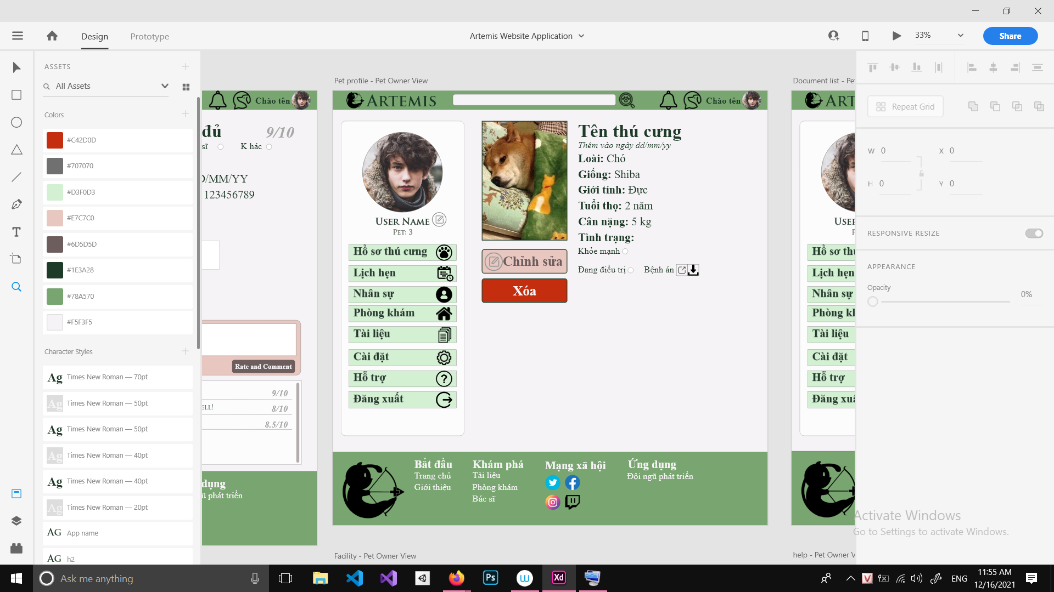
From | Condition | Control Type | Target | Notes
1 | View | Image | Show pet avatar
2 | View | Text view | Show pet name
3 | view | Text view | Show added date
4 | View | Text view | Show species
5 | View | Text view | Show breed
6 | View | Text view | Show gender
7 | View | Text view | Show age
8 | View | Text view | Show weight
9 | View | Text view | Show status
10 | Input | Checkbox | Check if pet is healthy
11 | Input | Checkbox | Check if pet is unhealthy
12 | View | Text view | Show text
13 | Click | Button | Click to show pet health report
14 | Click | Button | Click to download pet health report
15 | Click | Button | Click to edit pet profile | Pet Owner’s View
16 | Click | Button | Click to add health report | Vet’s View
17 | Click | Button | Click to remove pet from list

UI 11: Appointment
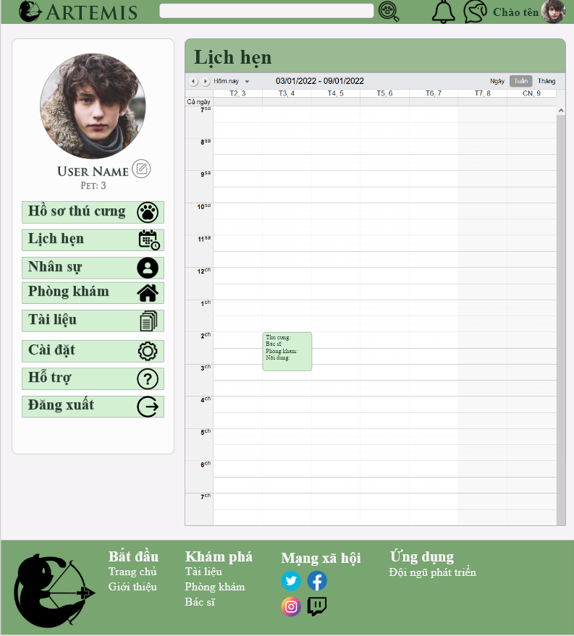

From | Condition | Control Type | Target | Notes
1 | View | Text View | Show page title | <Lịch hẹn>
2 | View | Calendar | Show real time calendar
3 | Click | Container | Click to open appointment pop up
4 | Click | Button | Click to add appointment
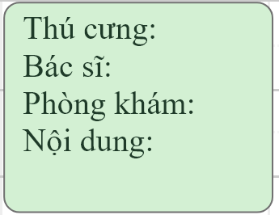
Appointment Item

From | Condition | Control Type | Target | Notes
1 | View | Text view | Show pet name
2 | View | Text view | Show vet name
3 | View | Text view | Show facility name
4 | View | Text view | Show brief description of the appointment

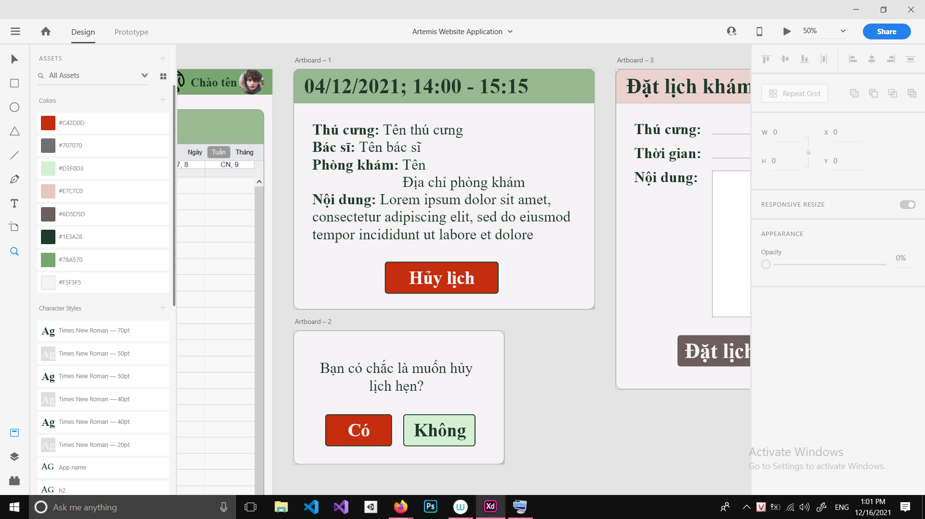
Appointment pop-up

From | Condition | Control Type | Target | Notes
1 | View | Text view | Show date and time for the appointment
2 | View | Text view | Show pet name
3 | View | Text view | Show vet name
4 | View | Text view | Show facility name
5 | View | Text view | Show brief description of the appointment
6 | Click | Button | Click to cancel appointment

From | Condition | Control Type | Target | Notes
1 | View | Text view | Show warning text
2 | Click | Button | Click to cancel appointment
6 | Click | Button | Click to close pop up

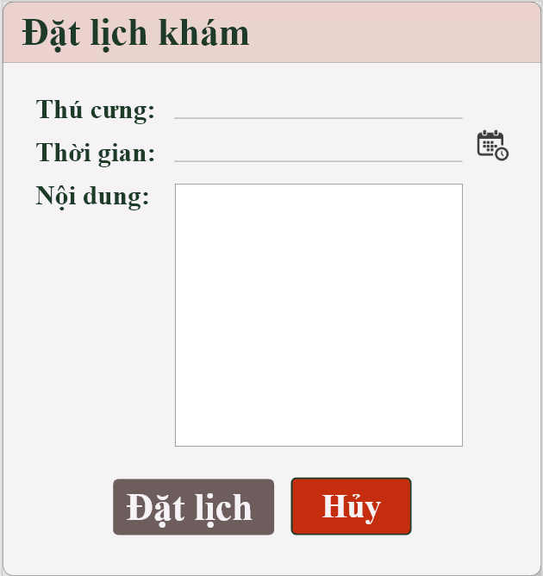

From | Condition | Control Type | Target | Notes
1 | View | Text view | Show text | <Đặt lịch khám>
2 | View | Text view | Show text | <Thú cưng>
3 | View | Text view | Show text | <Thời gian>
4 | View | Text view | Show text | <Nội dung>
5 | Input | Drop down list | Pick pet from pet list
6 | Input | Date | Pick date
7 | Input | Edit text | Input brief description for the appointment
8 | Click | Button | Click to request appointment
9 | Click | Button | Click to cancel

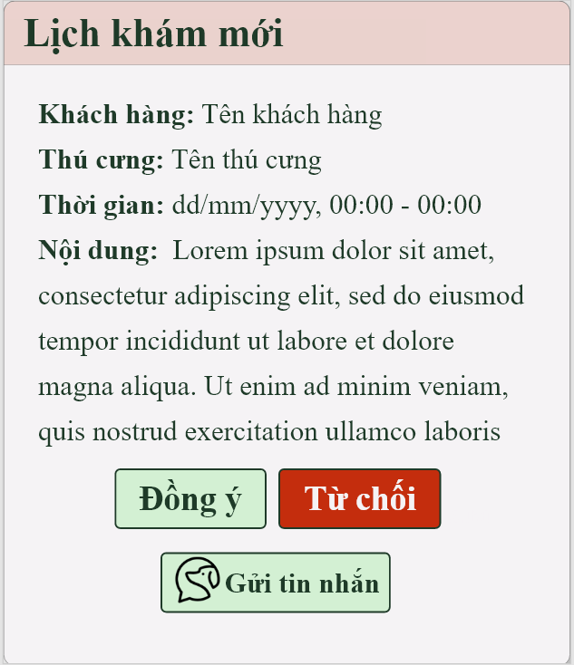
Appointment request (Vet’s view)

From | Condition | Control Type | Target | Notes
1 | View | Text view | Show pet owner’s name
2 | View | Text view | Show pet name
3 | View | Text view | Show appointment date
4 | View | Text view | Show brief description of the appointment
5 | Click | Button | Click to add appointment
6 | Click | Button | Click to refuse appointment
7 | Click | Button | Click to start chatting with pet owner

UI 12: Vet list
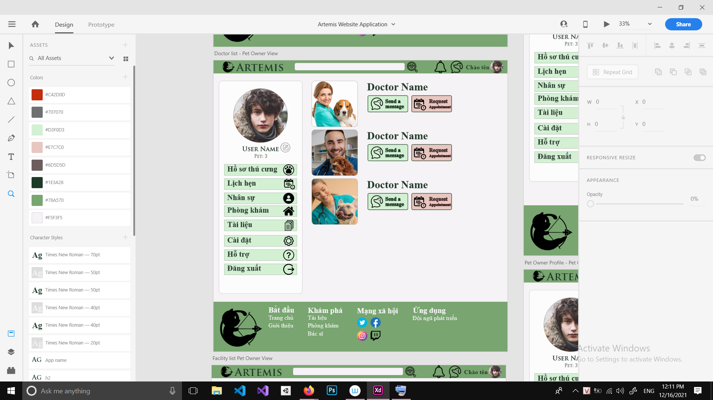
From | Condition | Control Type | Target | Notes
1 | Click | Container | Click on vet item to go to vet profile
2 | Click | Button | Click to add vet profile | Admin’s view

From | Condition | Control Type | Target | Notes
1 | View | Image | Show vet avatar
2 | View | Text View | Show vet name
3 | Click | Button | Click to start chatting
4 | Click | Button | Click to request appointment | Pet owner’s view
6 | Click | Button | Click to remove vet | Admin’s view

UI 13: Vet profile
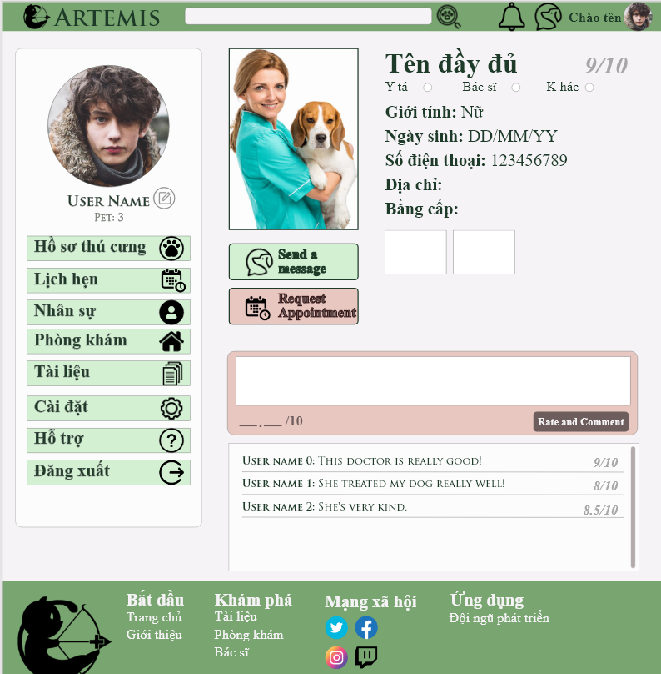

From | Condition | Control Type | Target | Notes
1 | View | Image | Show vet avatar
2 | View | Text view | Show vet name
3 | view | Text view | Show rating
4 | View | Checkbox | Checked if the staff is a nurse
5 | View | Checkbox | Checked if the staff is a vet
6 | View | Checkbox | Checked for other option
7 | View | Text view | Show gender
8 | View | Text view | Show DOB
9 | View | Text view | Show phone number
10 | View | Text view | Show address
11 | View | Text view | Show phone number
12 | Click | List | Click on list item to show full file
13 | Click | Button | Click to start chatting
14 | Click | Button | Click to request appointment | Pet Owner’s View
15 | Click | Button | Click to edit vet profile | Admin and Vet’s View
16 | Input | Edit text | Input comment | Pet Owner’s view
17 | View | Container | Show list of previous comments and rating

UI 14: Facility List
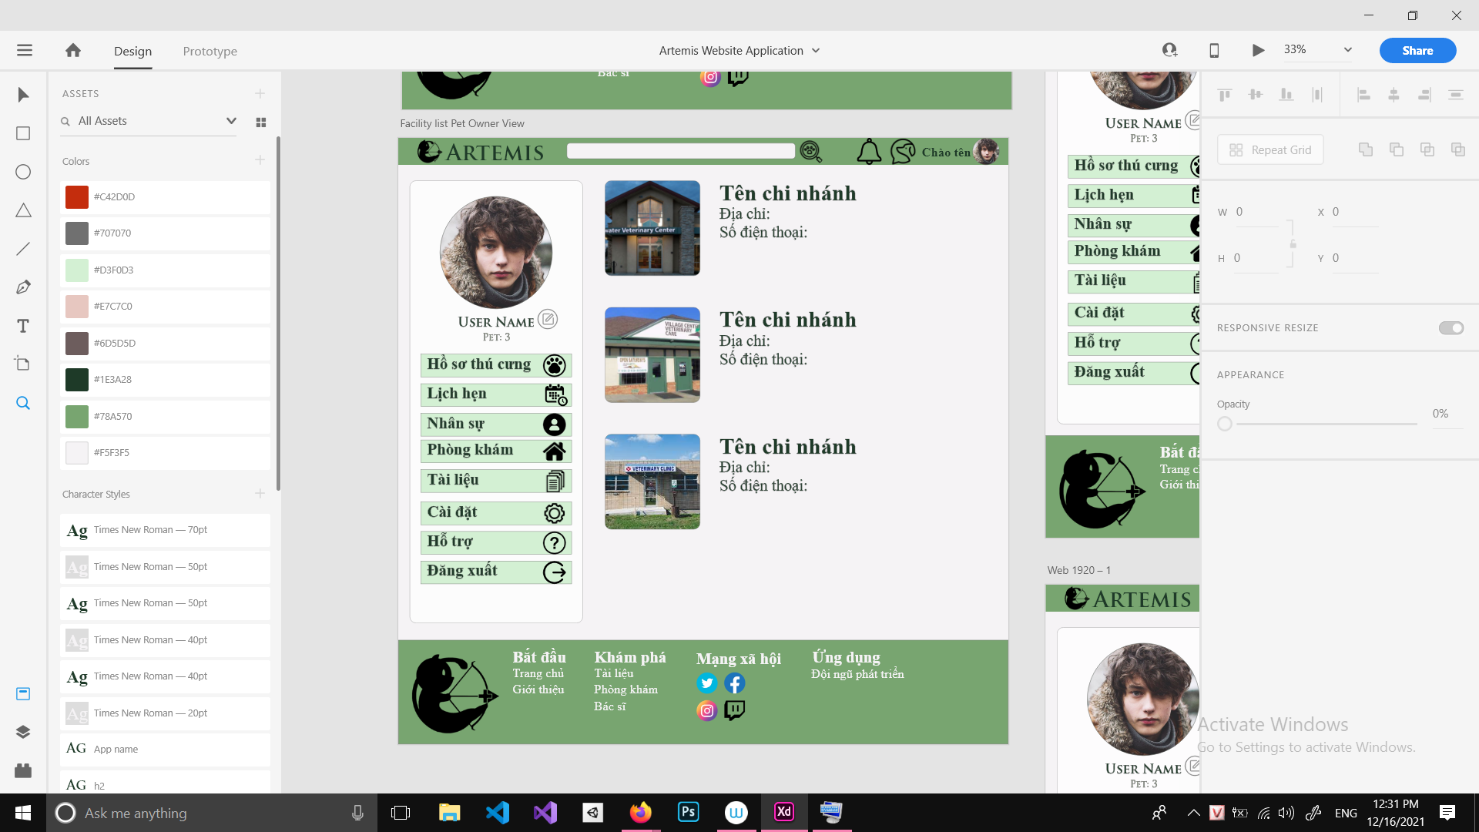

From | Condition | Control Type | Target | Notes
1 | Click | Container | Click on facility item to go to facility profile
2 | Click | Button | Click to add facility profile | Admin’s view

From | Condition | Control Type | Target | Notes
1 | View | Image | Show facility avatar
2 | View | Text View | Show facility name
3 | View | Text View | Show facility address
4 | View | Text View | Show facility phone number

UI 15: Facility profile
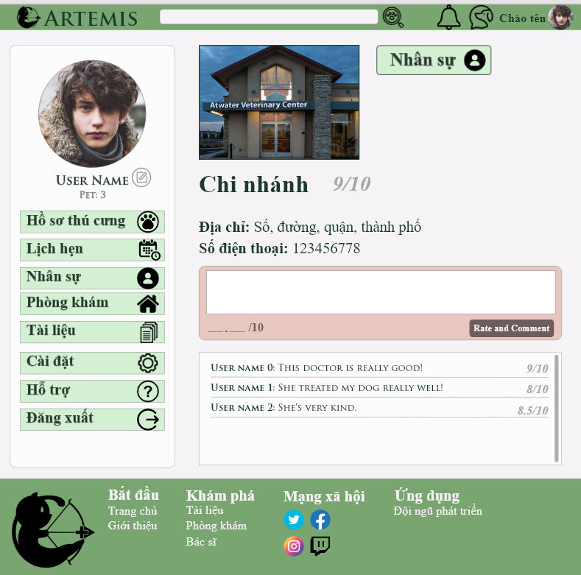

From | Condition | Control Type | Target | Notes
1 | View | Image | Show facility avatar
2 | Click | Button | Click to move to vet list
3 | View | Text view | Show facility name
4 | view | Text view | Show rating
5 | View | Text view | Show address
6 | View | Text view | Show phone number
17 | Click | Button | Click to edit facility profile | Admin’s View
18 | Input | Edit text | Input comment | Pet Owner’s view
19 | View | Container | Show list of previous comments and rating

UI 16: Document
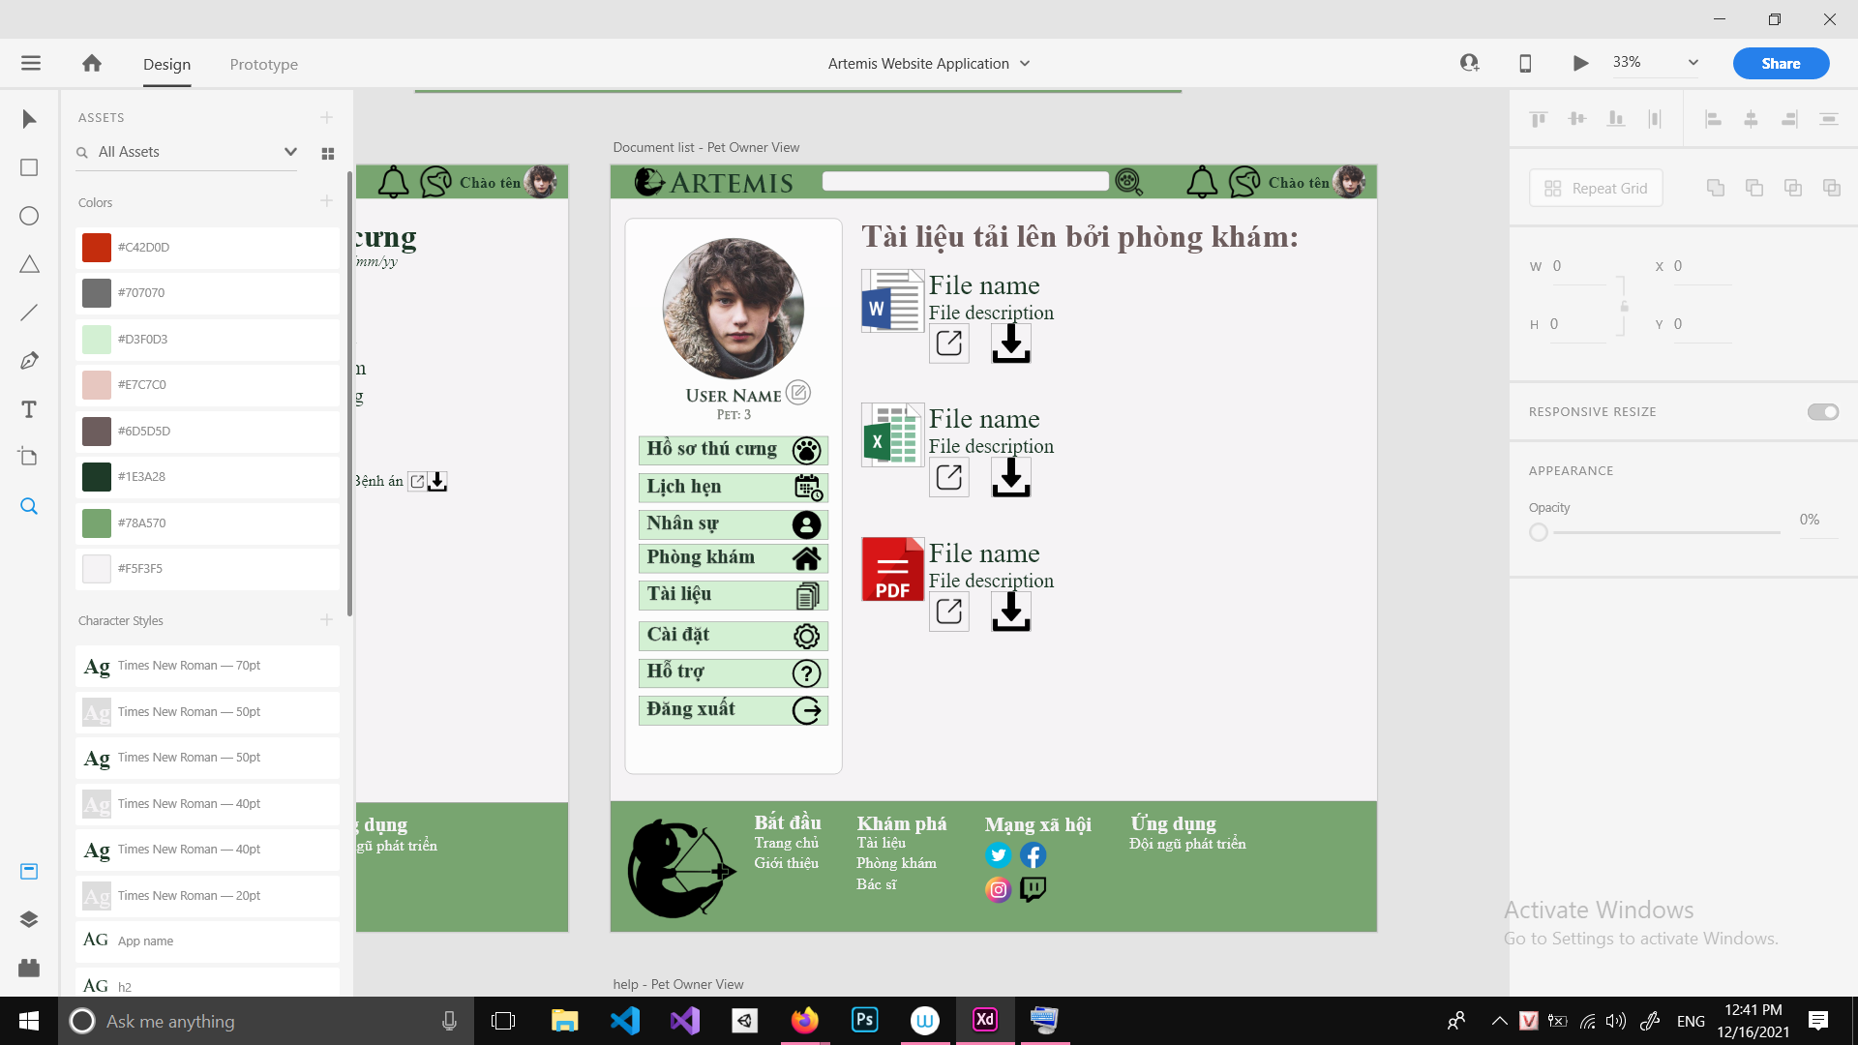

From | Condition | Control Type | Target | Notes
1 | View | Text view | Show text
2 | Click | Container | Click on document item to view it
3 | Click | Button | Click to upload | Admin and vet’s view

From | Condition | Control Type | Target | Notes
1 | View | Image | Show file type
2 | View | Text View | Show file name
3 | View | Text View | Show file description
4 | Click | Button | Click to view file
5 | Click | Button | Click to download file
6 | Click | Button | Click to remove file | Admin’s view

UI 17: Help
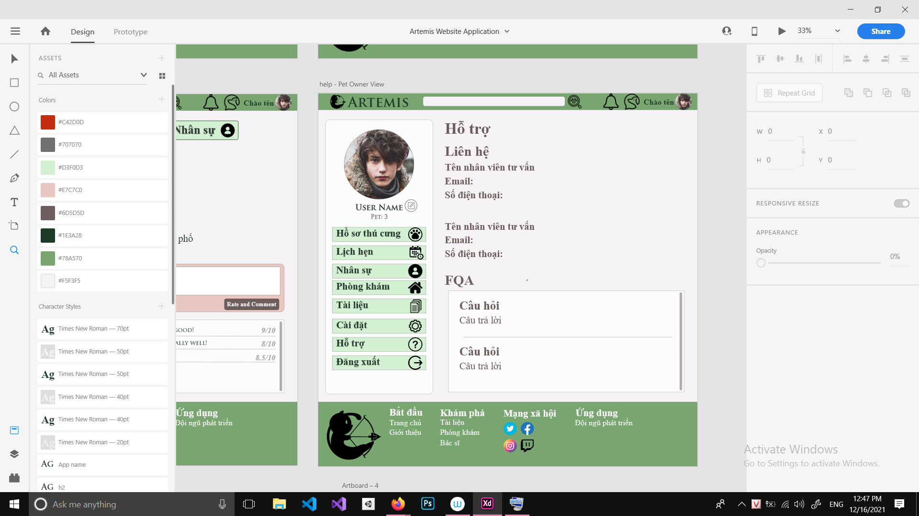

From | Condition | Control Type | Target | Notes
1 | View | Text View | Show page title
2 | View | Text view | Show text
3 | view | Text view | Show CS staff name
4 | view | Text view | Show CS staff email
5 | view | Text view | Show CS staff phone number
6 | view | Text view | Show CS staff name
7 | view | Text view | Show CS staff email
8 | view | Text view | Show CS staff phone number
9 | View | Text view | Show text
10 | View | Container | Show list of previous FAQs

UI 18: Search
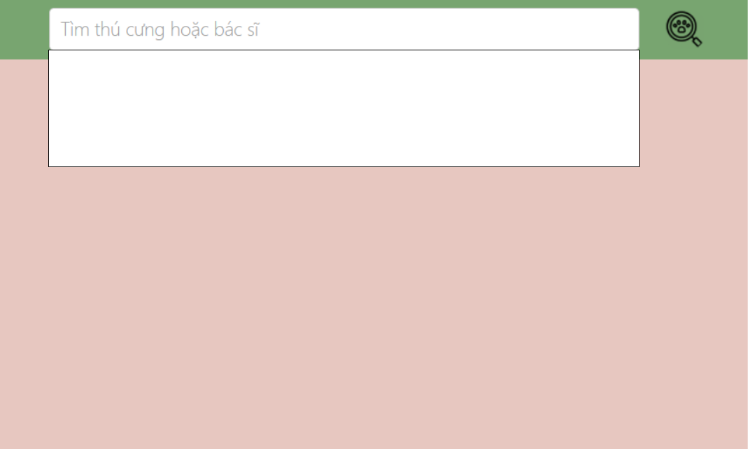

From | Condition | Control Type | Target | Notes
1 | Input | Edit Text | Input pet or veterinarian by name
2 | Click | Button | Click to find items
3 | View | Text view | Show results

UI 18: Chat
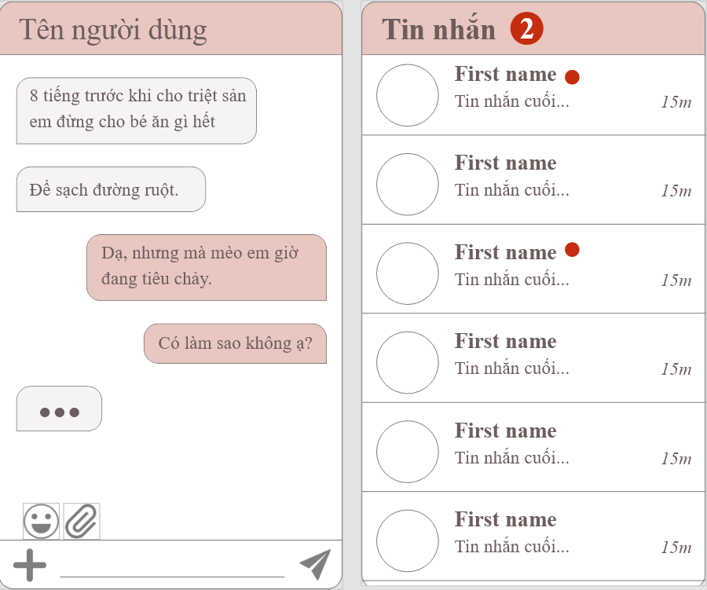
From | Condition | Control Type | Target | Notes
1 | View | Text View | Show title chat/ name
2 | View | Text View | Show content
3 | Input | Edit Text | Input content


View Action ( Attachment and share locate)

UI 19: Liquidation
From | Condition | Control Type | Target | Notes
1 | View | Text View | Show title
2 | View | Text View | Show text
3 | Click | Button | Click to create post
4 | Click | Button | Click to show action (edit/delete)
5 | View | Img | Show Img for item
6 | Click | Button | Click to navigate to page detail
7 | View | Text View | Show time

UI 20: Liquidation detail
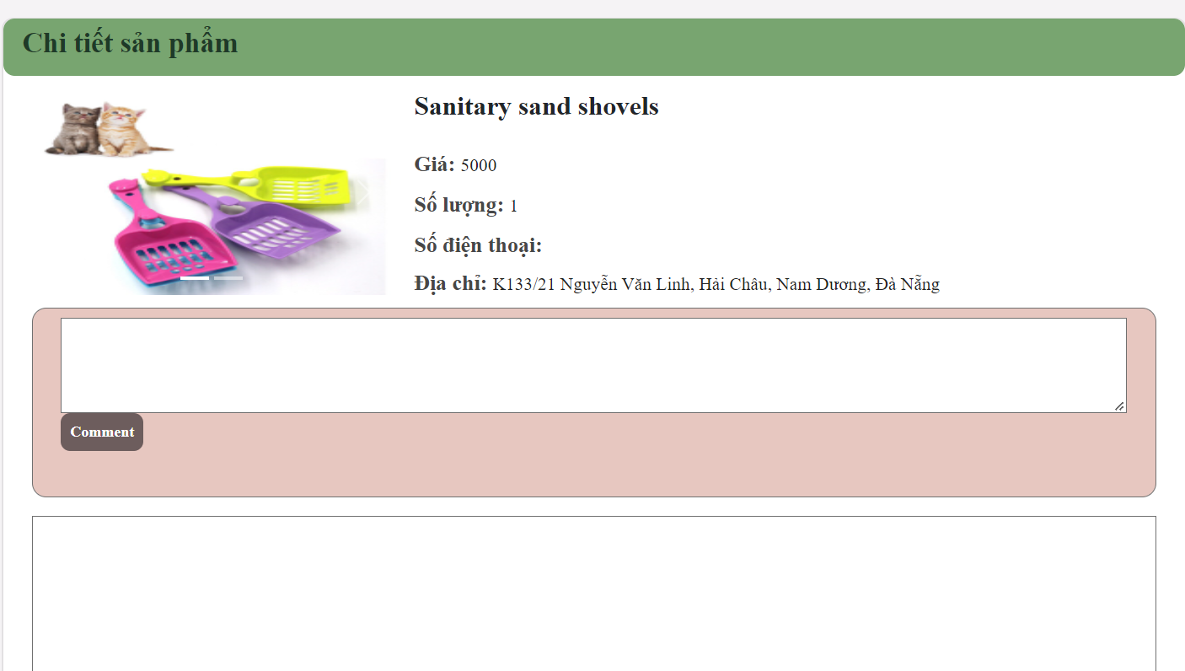

From | Condition | Control Type | Target | Notes
1 | View | Text View | Show title
2 | View | Text View | Show text
3 | View | Text View | Show price
4 | View | Text View | Show quality
5 | View | Text View | Show phone number
6 | View | Text View | Show address
7 | View | Edit Text | Input comment
3 | Click | Button | Click to finish the comment
4 | View | Text View | Show all comment

UI 21: Liquidation post

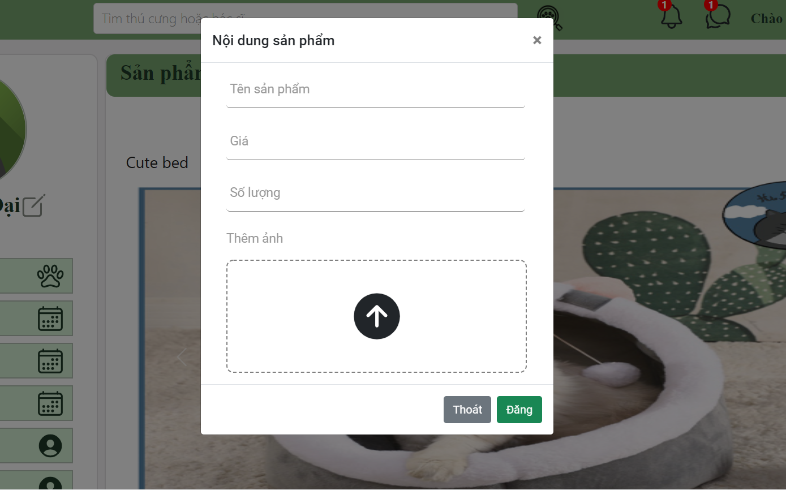
From | Condition | Control Type | Target | Notes
1 | View | Text View | Show title
2 | Input | Edit text | Input product ‘s name
3 | Input | Edit text | Input price
4 | Input | Edit text | Input quantity
5 | Input | Img | Attach a photo of the product.
6 | Click | Button | Click to exit the form
7 | Click | Button | Click here to finish the post.

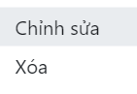
View Action Button

UI 22: Statistical
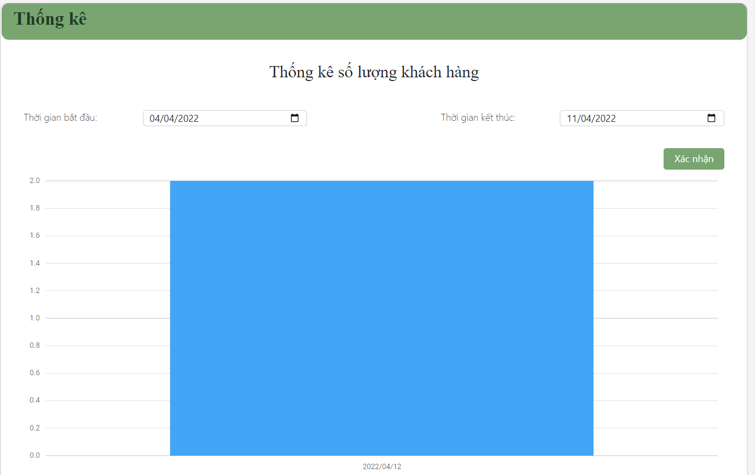
From | Condition | Control Type | Target | Notes
1 | View | Text View | Show title
2 | Input | Edit Timepicker | Input Start Time
3 | Input | Edit Timepicker | Input End Time
4 | Click | Button | Click here to finish the condition
5 | View | Chart | Show statistical

UI 23: Video call
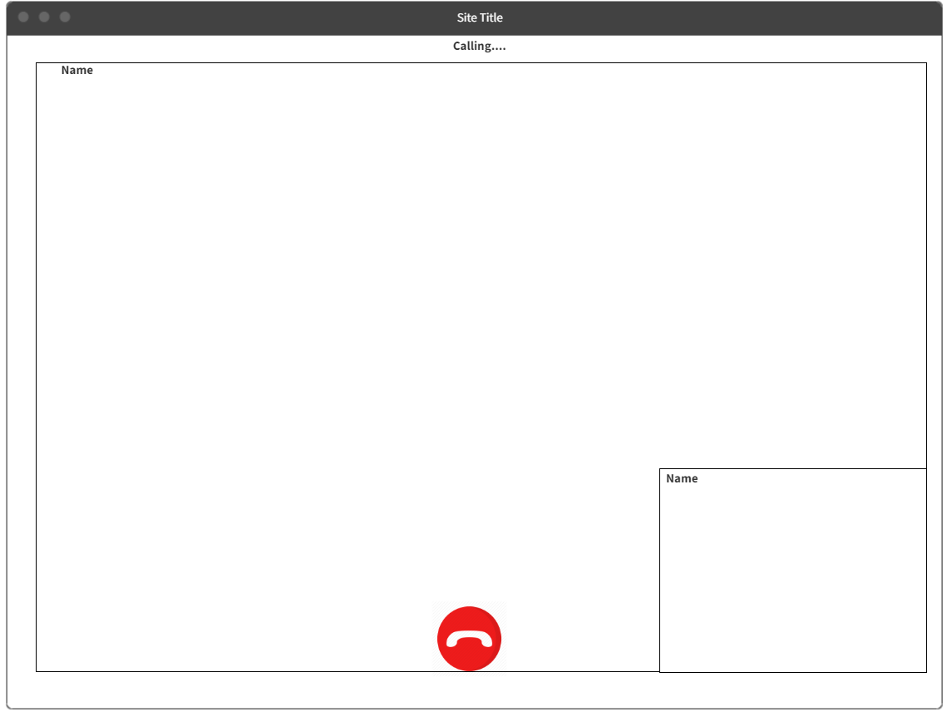
From | Condition | Control Type | Target | Notes
1 | View | Text View | Show status video call
2 | View | Video | Show screen user
3 | View | Text View | Show user’s name
4 | Click | Button | Cancel the video call

UI 24: Notification dropdown
